

Project Report

Course: MKT 440



Jagannath Kharel.

September 21, 2022

**1. SEO Performance Analysis of Your Client’s Website**

Weibring Golf Club at Illinois State University, designed in 1962, is one of the oldest and most famous golf clubs in Normal Bloomington. It has been renamed Weibring Golf Club at Illinois State University in honour of ISU Alumnus D.A. Weibring and his many contributions to the ISU Golf Teams, the golf course, and the university. This report analyses the Search Engine Optimization (SEO) score to measure how well the user-facing and technical aspects of the site contribute to SEO and, ultimately, higher rankings and organic traffic. SEO score is consistently a significant driver of growth and customer acquisition websites; this the SEO report provides insight into the company website and finds what the need to improve on to grow.

Overall, an SEO score indicates that the website (<https://www.isugolf.com/>) is not meeting quality standards and is not satisfactory for mobile users for SEO. Though the website is comparatively better than its local competitors, its content, user experience, and mobile usability made the website client unfriendly.  The score was just a good (72) and it is identified 15 critical issues required to solve for better optimization.  Performance metrics shows only 48% which is very poor and the use of mobile search such as time to interaction (10%), Contentful paint (21%) and snipper (67%) and speed index has more issues than using desktop.

The content score is satisfactory, but the Google Snippet, first contentful paint and time to interaction which is required to optimize Meta description and URL. Meta viewport score and uses passive even listeners, iFrame, text/HTML ratio.  Some words from the page title are not used within the pages content. Sitemap, links are Crawlable are null. Although the website is popular in Facebook, and social plugin, it can use Twitter (current score: 25%) card effectively. Disabling zooming is problematic for users with low vision who rely on screen magnification to properly see the contents of a web page.

1. **Keywords Search**

According to a study, individuals are searching for "golf clubs near me" more frequently in Bloomington and other locations, with "gold golf club" ranking least among the top 10.

1.   golf clubs near me

2.   golf clubs in Bloomington IL

3.   best golf clubs in Normal Bloomington IL

4.   cheap golf clubs

5.   golf discount

6.   golf deals

7.   golf discounts near me

8.   gold golf club

9.  Best golf courses in Bloomington, IL

10. Golf sports in Bloomington IL

The above keywords have a high volume in our area. As some proposed keywords that can be utilized for the campaign, tee times near me shows the greatest potential, followed by golf discounts, and public golf courses will have the least impact. With 5,000 impressions, 25% conversion will cost about $30 per day, with an average CPC of $4.70. The following keywords can be taken for the lead campaign.

1.     free times near me

2.     golf discount

3.     golf clubs

4.     golf near me

5.     golf courses near me

6.     golf course

7.     golf

8.     golf clubs near me

9.   best golf clubs

10.   public golf courses near me

**3. Competitor Analysis**

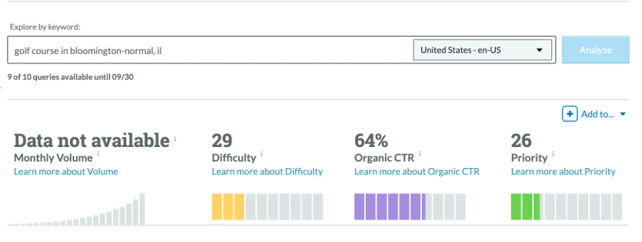

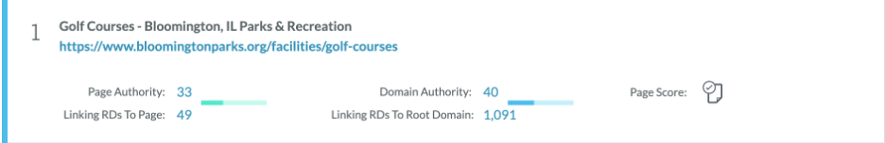

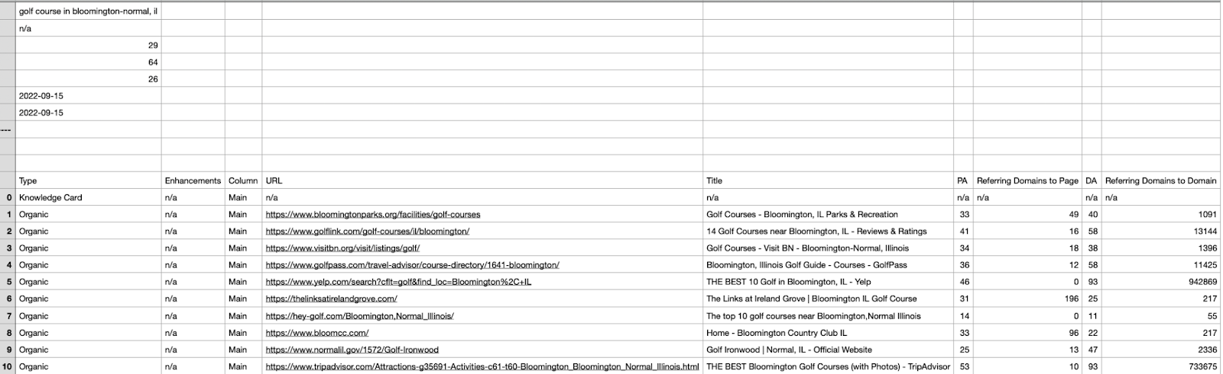

The pictures above show that The Golf Courses-Bloomington, IL Park & Recreation has 33 in terms of Page Authority, 40 of Domain Authority, 49 of Linking RDs To Page, and 1,091 Linking RDs To Root Domain.

  Page Authority is used to measure the strength of this website is 33 out of 100. This score is pretty. Domain Authority expects the ranking of this website is 40 out of 100. It means that the ranking of this website is pretty hard to rank in SERP (29) based on Moz's prediction. The Linking RDs To page is 49. It has a very low number of client access to the domains providing links to the client's page. Compared with Linking RDs To Root Domain is 1,091, it has a very high number of the client's site providing internal links to navigate between pages.

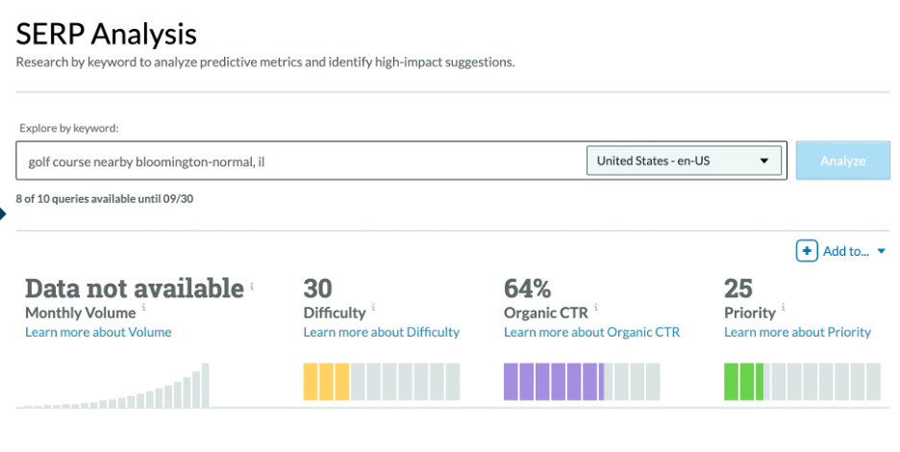

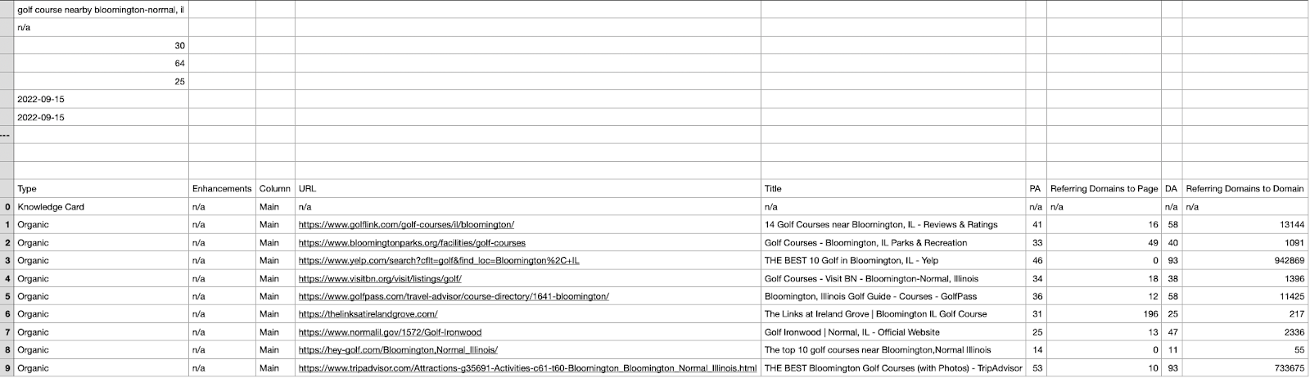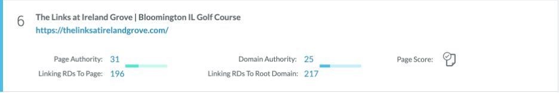

  The pictures above show that The Link at Ireland Grove Bloomington IL Golf Course has 31 in terms of Page Authority, 25 of Domain Authority, 196 Linking RDs To Page, and 217 Linking RDs To Root Domain.

Page Authority is used to measure the strength of this website is 31 out of 100; this score is pretty low. Domain Authority expects the ranking of this website is 25 out of 100. It means that the ranking of this website is very easy to rank in SERP (30) based on Moz's prediction. The Linking RDs To page is 196. It has a good number of client access to domains providing links to the client's page. Linking RDs To Root Domain is 217 it has a good score of client's sites providing internal links to navigate between pages. There is a very close gap between the Linking RDs To Root Domain and Page.

**

In Competitive Research, the data shows that there is no data enough to analyse the competitor’s website.

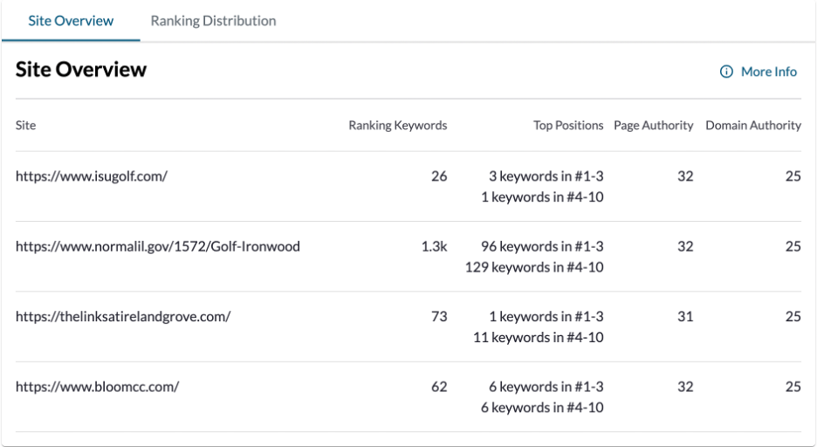

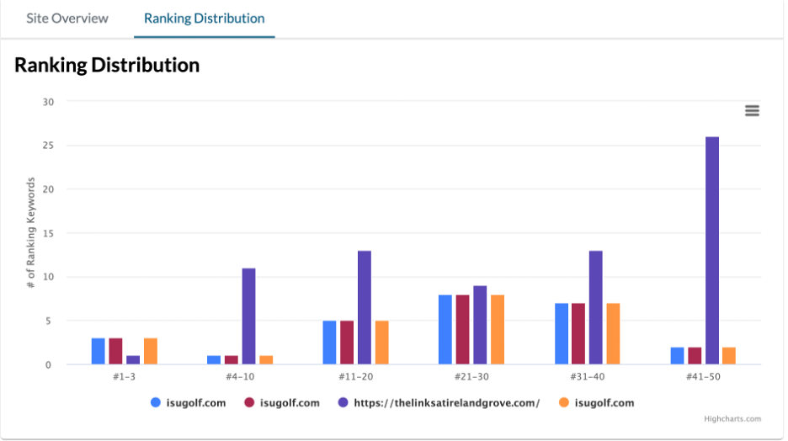

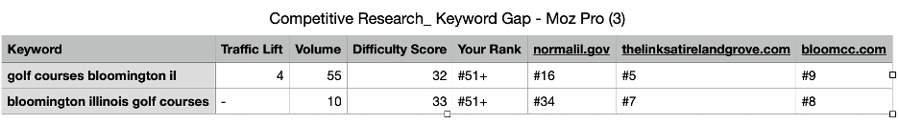

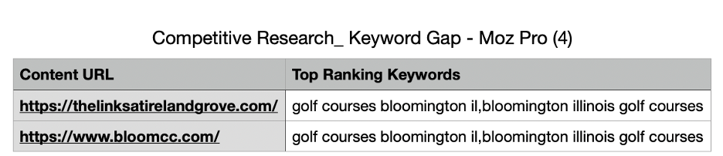

The figure above shows that these two websites use the keyword “golf courses Bloomington il, Bloomington Illinois golf courses.” To be in the top-ranking keywords.

1. **Competitor Analyses Using SEMRush**

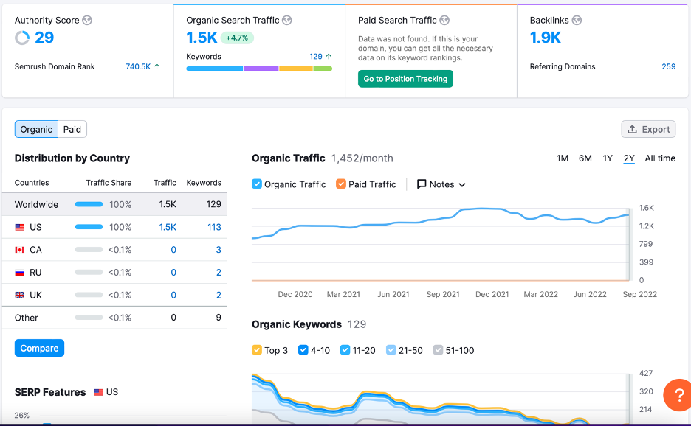

With the use of "SEMRush," the competitor overview assessments reveal that there is no competition between other nations, which is advantageous for this domain's ability to increase traffic. Given the nature of the company, there is very little activity because it is an expensive sport that only those who can afford such a lifestyle may participate in.

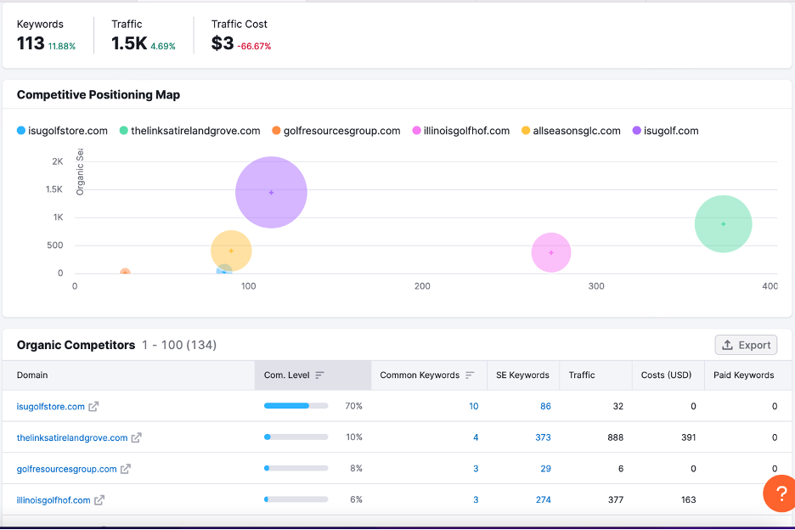

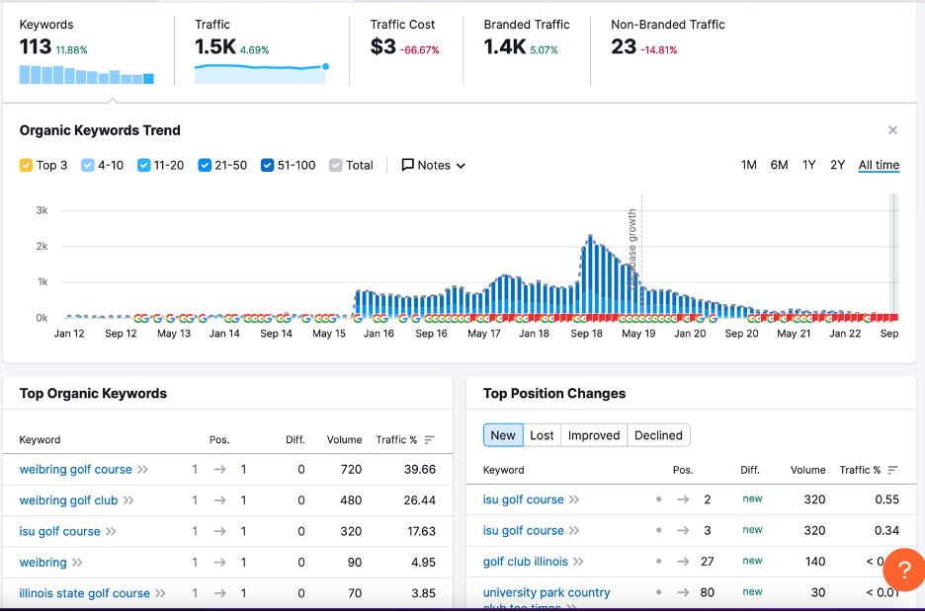

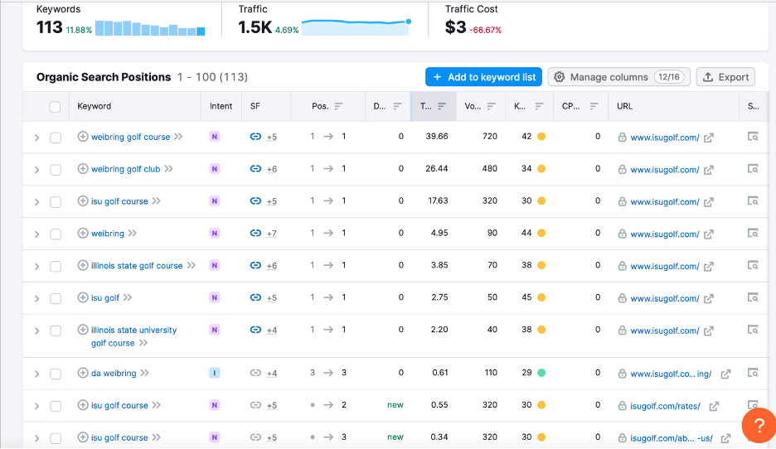

For "*www.isugolf.com*," the top organic keywords such as Weibring Golf Course/Club receive more traffic than others. Because it has more keywords linked to its business of origin and costs 66.7% less than its competitors, isugolf.com generates more traffic than its rivals, according to competitive assessments.

It is constructed with the goal of attracting traffic to its course and has one of the greatest distribution positions in the organic category.

**5. Overall Summary of Suggestions for the Client's Website**

* 1. **Website presence on the Google Local Business List**

Yes, the weibring gulf club is shown on the Google local business list but ranked on beyond the top 5 golf clubs. According to SERP analysis, the company shows up in the business list; the company has room to strengthen to meet a quality standard and satisfy for SEO audit. The team recommends optimising the local listing of the company’s website with relevant content to make it user-friendly such as making the website compactable with mobile apps for better usability. Performance metrics are below the average, and the use of mobile searches, such as time to interact, is low, including inadequate contentful paint.

According to the My Google Analytics, the following key recommendations are made to boost search engine optimization:

* the company is advised to invest time and resources into growing organic traffic for the last longer result and more conversions.
* Attracting organic traffic through SEO is free, and it is advised that the company create a positive website user experience and content with significant value.
* The next keyword research and value-rich content include related keywords in body copy, subheadings and images and adequate context to help google accurately understand what they’re talking about.

**5.2. Comparison of the companies’ tactics and strategy for pops up the site**

The three competitors are seen on the first page of SEO, and their comparative SEO tactics and specific information in google searches are mentioned in the table below. For this, we searched “Best golf clubs in Bloomington, IL” or “Best golf courses in Normal, IL” on google.

|  |  |  |  |  |
| --- | --- | --- | --- | --- |
| Rank | **Rank on Google** | | | |
| **Rank 11** | **Rank 1** | **Rank 2** | **Rank 3** |
| Name | https://isugolf.com/ | <https://www.normalil.gov/1572/Golf-Ironwood> | <https://www.bloomingtonparks.org/facilities/golf-courses/prairie-vista-golf-course> | <https://www.bloomingtonparks.org/facilities/golf-courses/highland-park-golf-course> |
| Strategy | Less competitive edge on contents and marketing results | Competetive and marketing stretgical on contents and links on the websites with many features for SEO | Efforts seen making  it competetive and marketing it with with enrich contents and links on the websites | Clients’ friendly contents and well suited information for SEO |
| Keywords | Non-associated and unlinked keywords in heading, titles and pages | Carefully matched keywords and integrated heading, titles, and pages | Well-fitted contents with details explanation | Adequate and linked keywords, repeated in heading, pages and titles. |
| Contents | Unspecific contents and lack of specific information | Relevant contents and enriched information about the company and its service (rates and facilities and schedules are well mentioned) | Detailed contents and adequate information about services, rates, and schedule etc (rates and facilities and schedules are well mentioned). | Concise contents and adequate information about services, rates and schedule etc (rates and facilities and schedules are appropriately mentioned) |
| Links and images | Weak images, meta description, and unlinked page title, content headings, canonical link, and unclear open graph. | Solid and clear images, well meta description, page title, XML sitemap, clear and specific content headings, and clear graph | Visible and clients’ friendly images, well meta description, page title, XML site map, clear and specific content headings, and clear graph | Good meta description, clear and visible images, linked page title, XML sitemap, clear and specific content headings, and good graphs. |
| Social media | Lack of social media management tools used and less aligned with mobile apps. | Well-supported social media management tool that supports in mobile apps as well as desktop | Good supported social media management tool that supports in mobile apps as well as website in desktop | Used social media management tools and mobile apps friendly contents and system |

* 1. **Suggestions for Improve Content**

The golf club is in an accessible area in Illinois State University, where thousands of young and adult people travel to the town to study and visit. The club content should have focused all prospective golf players. For the reachability and visibility of the club services, it must work on SEO. To attract more clients, the club must be competent in terms of dissemination and visibility in the local markets. It should focus on its images, meta description, page title, XML sitemap, content headings, canonical link, and open graph. For example, its quality, relevancy, and precise information are low, and images are found on the website with low resolution. The team highly advise the company to engage in users’ reviews and draw the attention of potential customers. Social media presence from the company is relatively invisible and ineffective.

The report suggests following the unified social media management tool that supports Facebook, Instagram, Twitter, YouTube, LinkedIn and google My business. Begin by collecting as much data and conducting thorough research on audience and competitors to help boost the SEO. On desktop and mobile, the website load on and off pages may attract backlinks but not it does not support the mobile apps adequately. The company should focus on the user experience and the patterns you detect through user behaviour reports. The content is king for the SEO, which should be linked, relevant and informative to attract traffic and generate long. It is highly recommended that the company should fairly invest time and efforts as required for revitalize SEO for website’s visibility and dissemination targeting its clients specially students and university communities.

Appendix.

Appendices:

**5.2 CSV file (SERP analysis)**

Appendix-5.2

